**Young Knocknaheeny & the local Cork working group, with affiliate Childhood Development Initiative Present**

Dolly Parton’s

Imagination Library

***What Is It?***

Dolly Parton’s Imagination Library is a book gifting programme for children aged 0-5. Each month a new, carefully selected book will arrive by post in your child’s name and be delivered directly to your home. Best of all it is free! There is no cost or obligation to your family.

***Who Is It For?***

All children under the age of five, living in the following areas;

**Knocknaheeny, Hollyhill, Churchfield, Gurranabraher, Mahon, Carrigtwohill, Ashbourne House** or **the Kinsale Road Centre**

***What Do I Need To Do?***

1. Be living in one of the following areas;

**Knocknaheeny, Hollyhill, Churchfield, Gurranabraher, Mahon, Carrigtwohill, Ashbourne House** or **the Kinsale Road Centre.**

1. Fill in an official registration form and send it to Grace Walsh (Young Knocknaheeny) or *Mahon contact* or *Carrigtwohill contact*.
2. Let us know anytime your address changes. Books are delivered by post every month to the address on the official registration form. ***If your child’s address changes, you will need to contact Grace Walsh on 086-8142233*** or *Mahon contact* or *Carrigtwohill contact* ***to continue receiving books.***

4. Explore, read and enjoy the books with your child!

***When Will I Receive Books?***

Six to eight weeks after your registration form has been received, books will begin arriving at your home and will continue until your child turns five or you move out of the area.

**Dolly Parton’s Imagination Library Official Registration Form** (one per child required)

Child’s **FULL** Name __________________________________________________________________________________________________________

Child’s Date of Birth __________/__________/__________ Sex: M F Phone ___________________________________________

Parent/Guardian’s Name _______________________________________________________________________________________________________________

Child’s Home Mailing Address __________________________________________________________________________________________________________

ADDRESS

__________________________________________________________________________________________________________

ADDRESS

__________________________________________________________________________________________________________

CITY COUNTY POST CODE

Parent/Guardian’s email address (please print very clearly): ___________________________________________________________________________________

“*This child is eligible for this scheme.*” ___________________________ _______________________________________________________

SIGNATURE OF PARENT OR GUARDIAN

I hereby explicitly consent to allow the Dollywood Foundation, Inc. to use the information provided herein for the purposes of participating in Dolly Parton’s Imagination Library book gifting program. To measure the benefits of this program we may create data sets with the information provided herein and share them with research and educational advancement partners. You agree to review our full Terms & Conditions and Privacy Policy by visiting imaginationlibrary.com. By signing and submitting this form you expressly consent to the terms set forth herein.

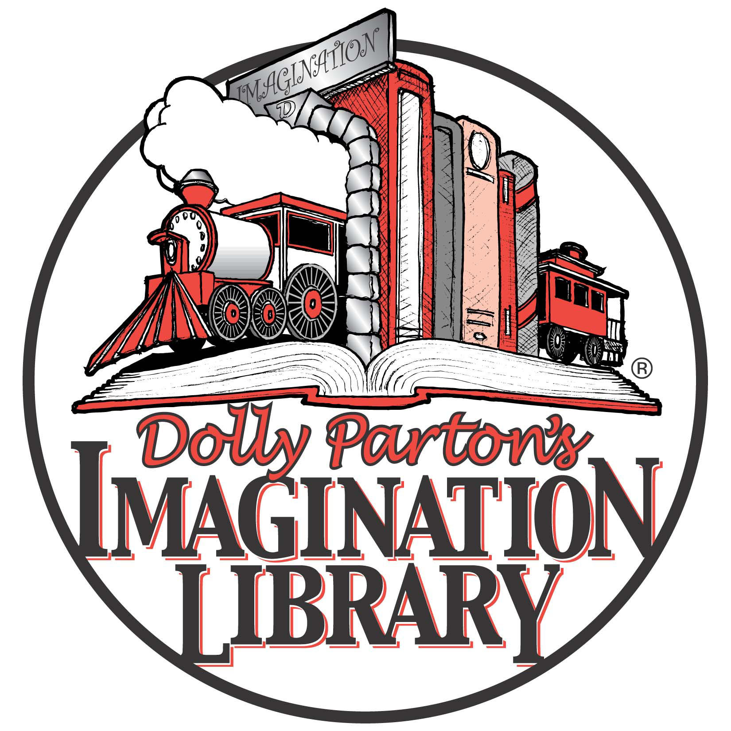

**Sign up your**

**child today!**

Simply fill out the form above and post to:

Grace Walsh *Mahon contact or*

Young Knocknaheeny *Carrigtwohill contact*

NICHE

HSE Building

Harbourview Road

Knocknaheeny

Cork